This document will include a user guide on how to use sage for a company. It will include pictures and also in writing on how to use the software.

When you first open up sage, you will be shown an option to choose which company’s accounts you want to open. For the sake of this guide we will open the ‘Garden Supplies Limited – ROI Set up2’ account as shown in the picture below.

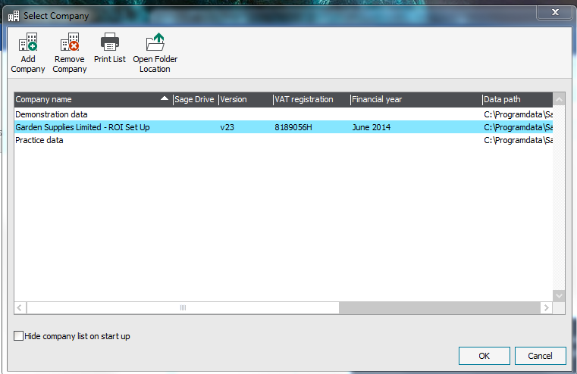

To begin we will import the data of a database that we already have. First press file on the top left hand corner. Once you’ve done that click on the import option and import and existing database.

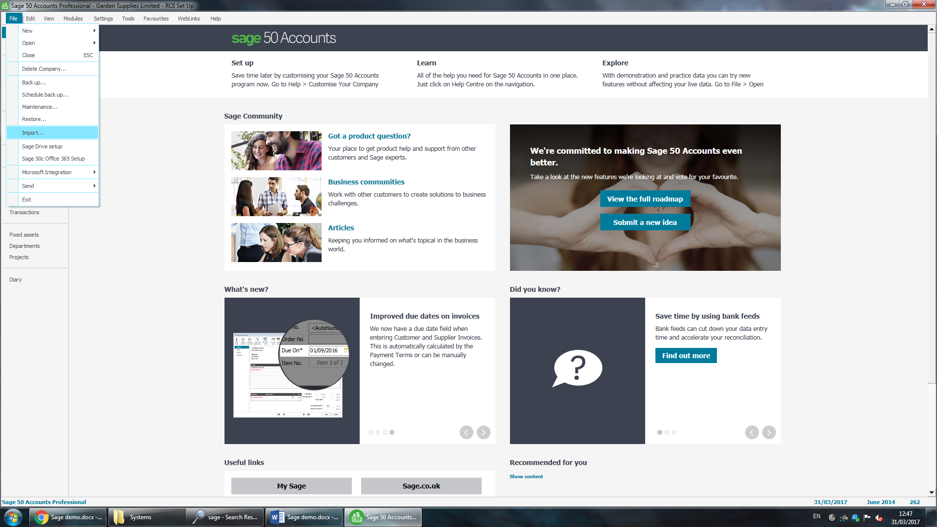

Once you import the database a pop up called Data Import should appear on your screen. The first table we will import will be the ‘Customers Table' so we will select the Customers Records on the list as shown and click next.

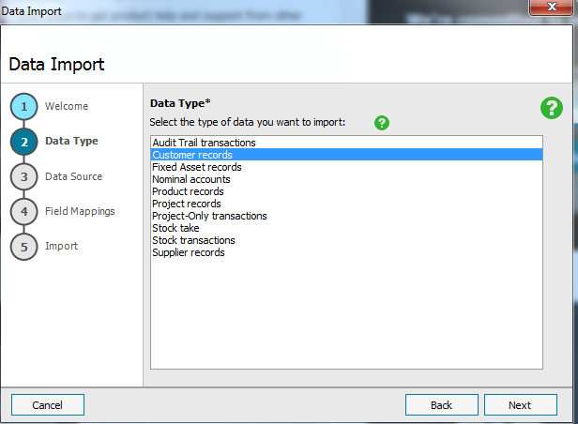

Then another pop up should open up. In this we will try match of the imported table fields with a suitable alternate that’s available on the Sage field list. For example, the Customer Code field would be best matched with the Account Reference Field. Some, like country, will be fielded for us automatically.

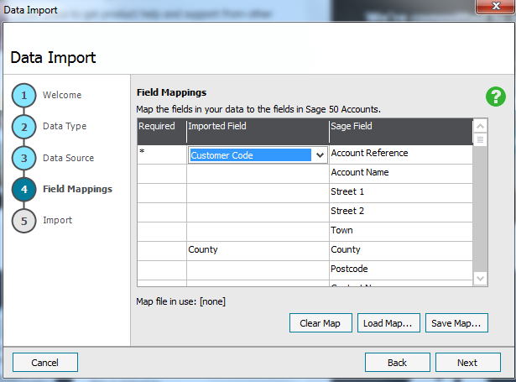

When you have selected all the appropriate fields for your imported table you can then press next. Until you see the Import button.

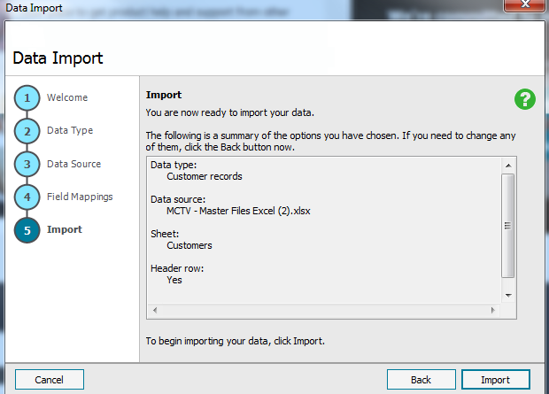

You have now successfully imported a table into your Sage Business account.

To change the details of your company you will first need to go to settings, and then to company preferences.

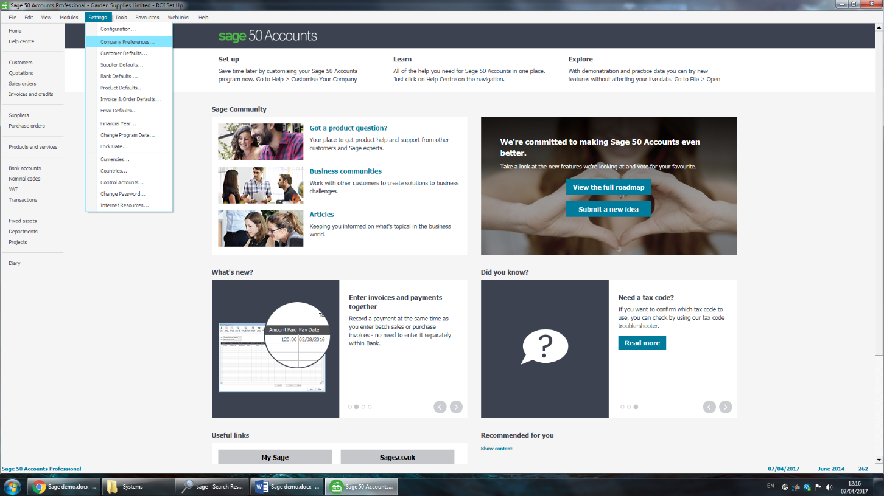

From the pop up you can select the Details tab and from here you can change any of the details of your company.

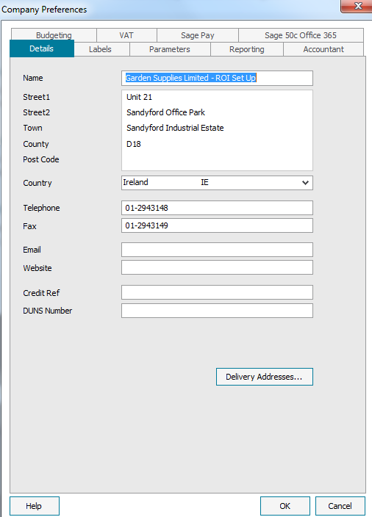

Here we have changed the name from Garden Supplies Limited to MCTV.

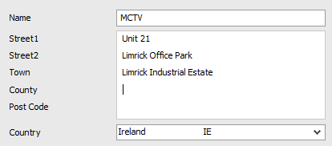

Now if you close the program down and reopen Sage the select company panel will show whatever name you chose for the company.

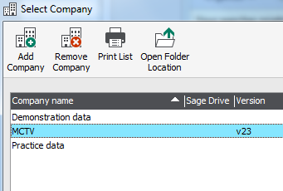

For security reasons, you may want to back up your information on sage. This can be done by going to file and clicking the backup option.

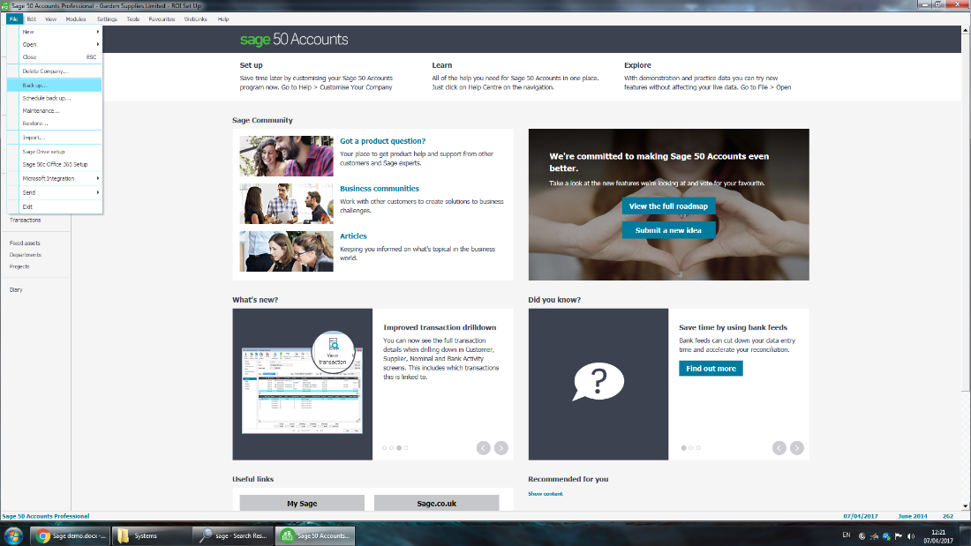

From the new panel, you can browse to the location you wish to your backup to be saved to. When you set a location all you need to do is press the OK button to begin the backup process.

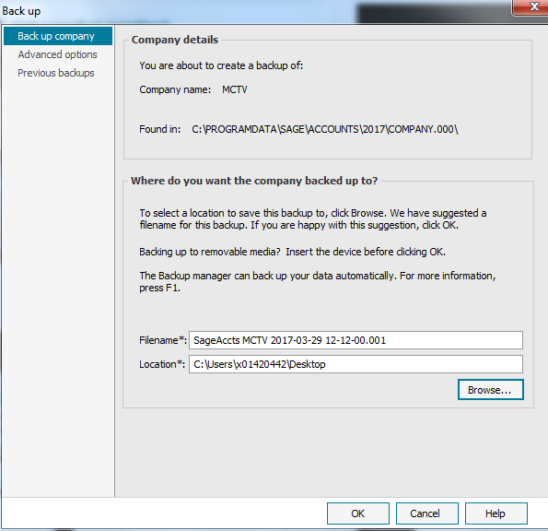

Once the backup is complete a pop up should update you on its success.

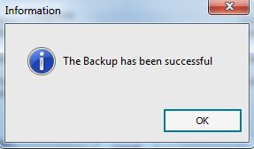

***Add a new record***

To add a new record to a table within Sage. It will be best to use a Wizard. To use one, you will first need to click on the Module button up the top, then at the bottom go to wizard, then new. For the sake of this example we will make a new record for the customer table.

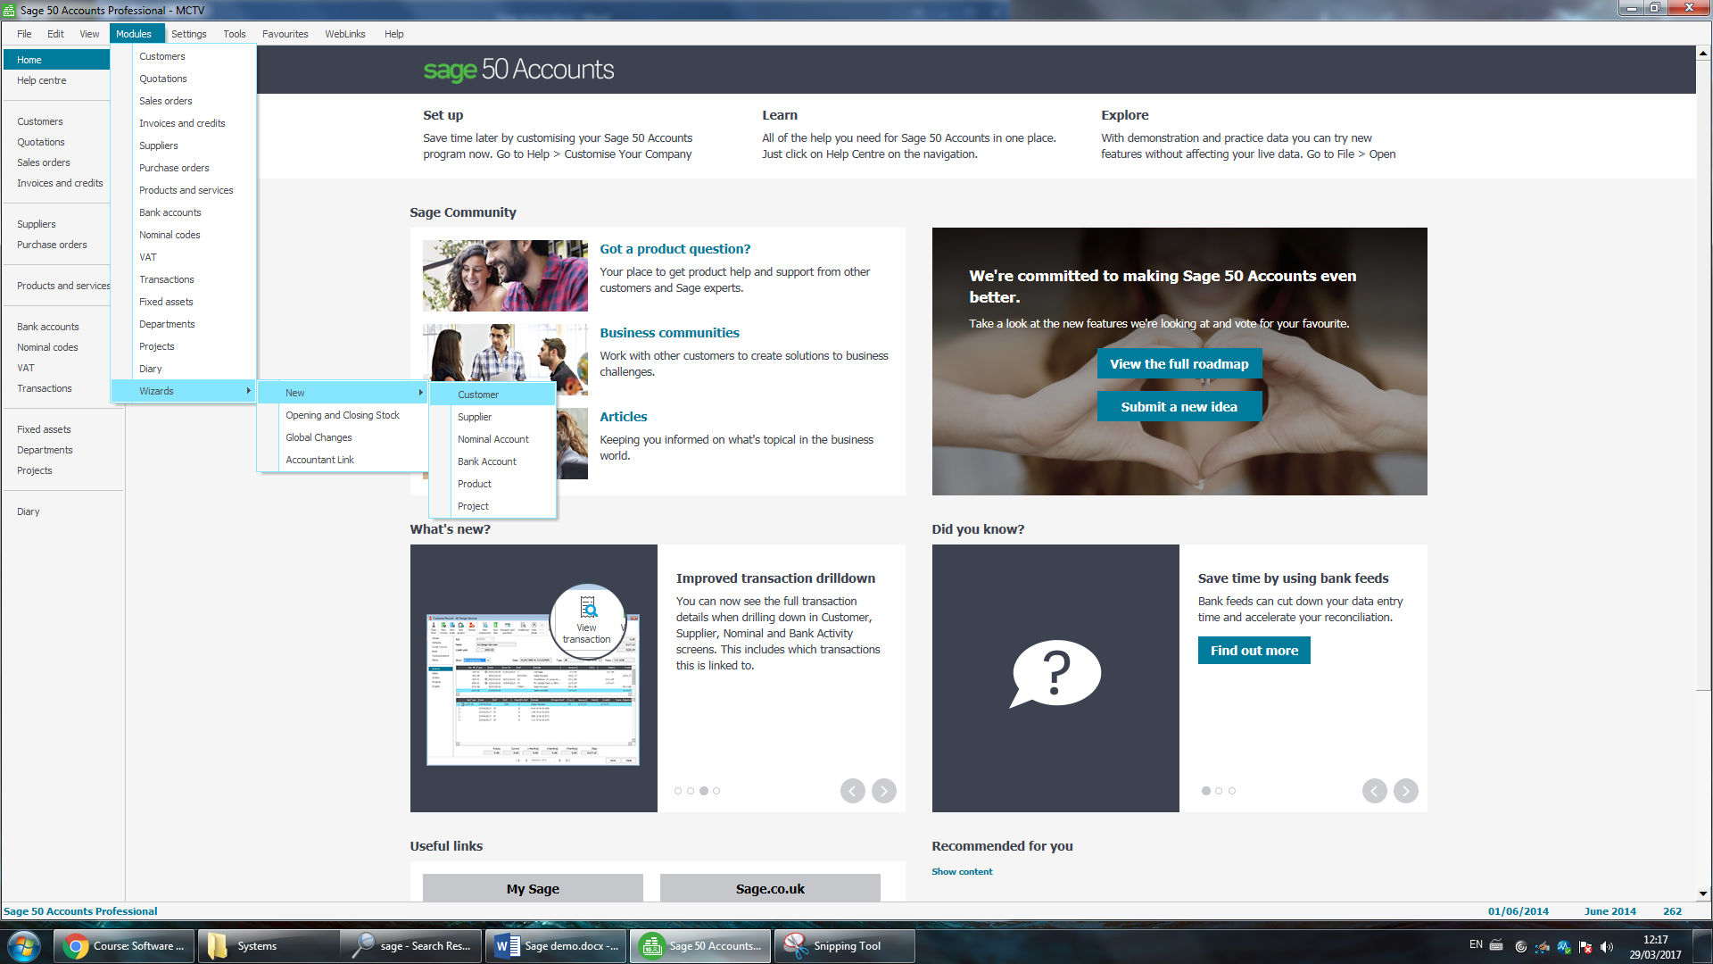

In the following pop up with will have a chance to enter all the information you know about the record you are creating. You just click next after each page is filled until you reach the end.

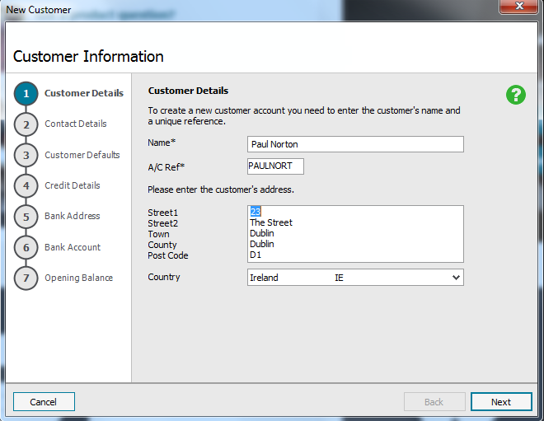

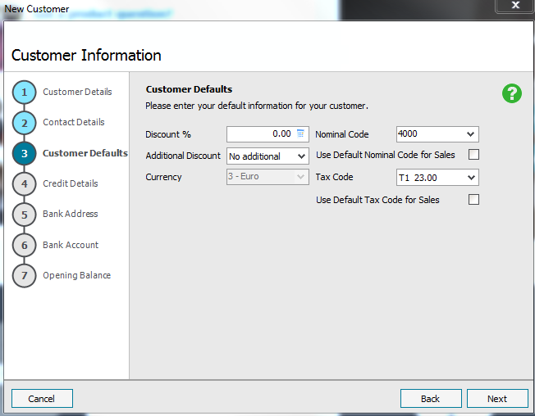

When you feel you have entered enough information and are ready to complete the creation of the report you simply need to press the Create button.

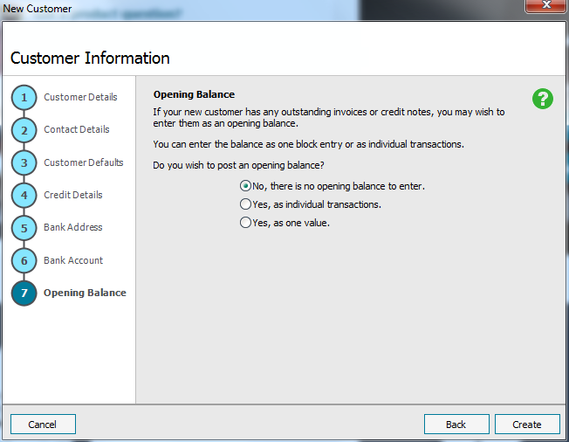

***Placing sales orders.***

To place an order for a company you need click the Module button and then Sales order option.

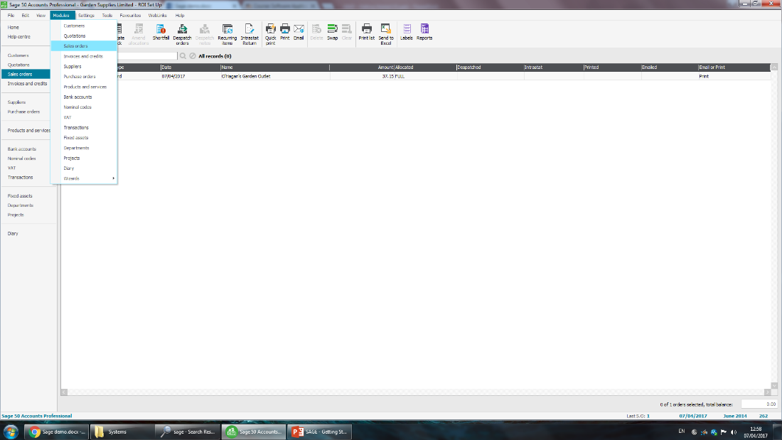

On the next page click new at the top.

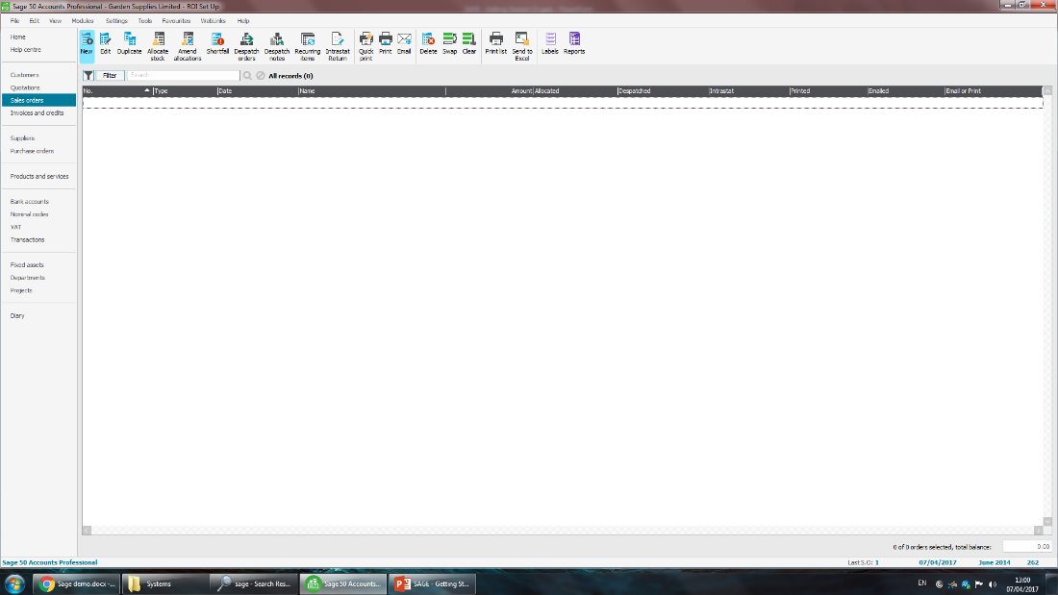

In the Products Sales Order Panel, you will need to select an account by pressing the drop-down menu beside the A/C* choice.

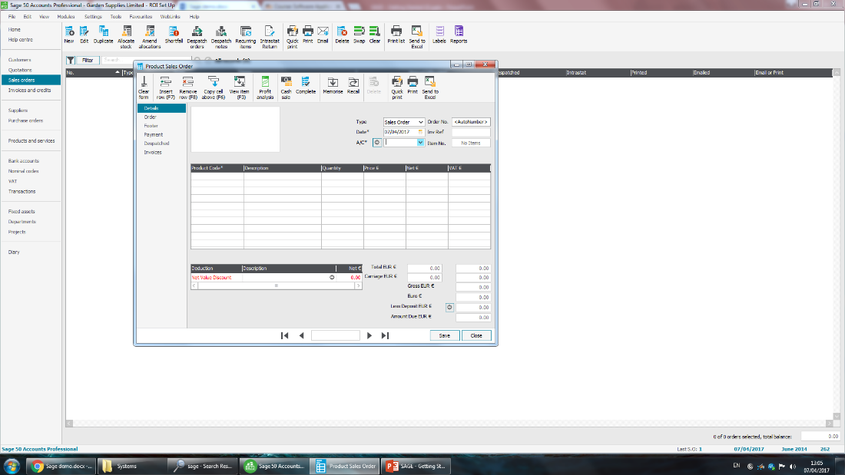

You will then select the product that the company is ordering by choosing the drop-down option under the Product description.

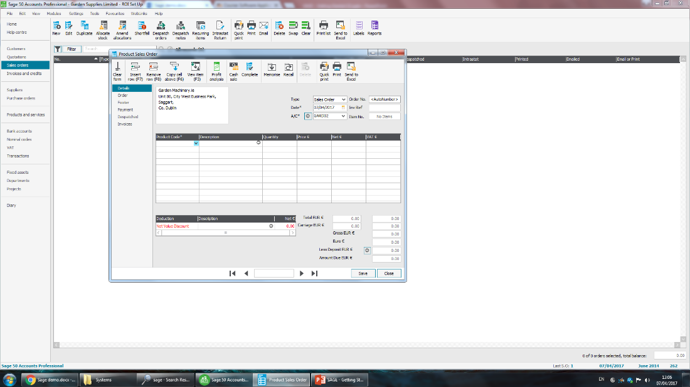

From there you can change the quantity of the item that’s being bought.

When you’re happy with the details given in the order just need to press the Save button.

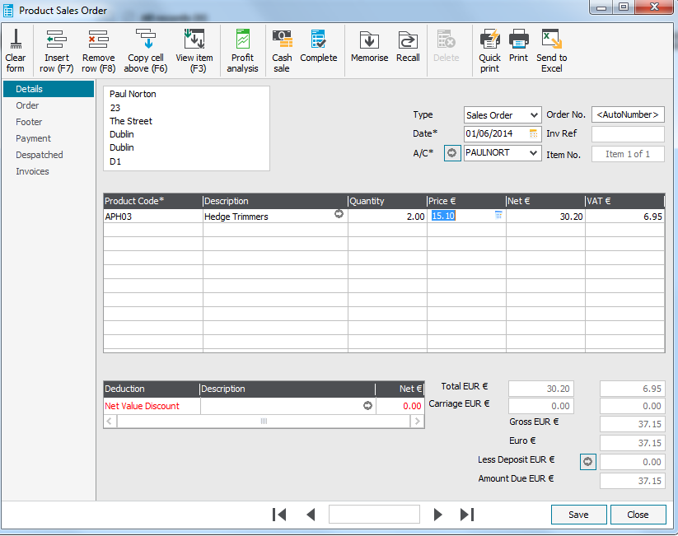

If your order is placed correctly it should appear on the screen.

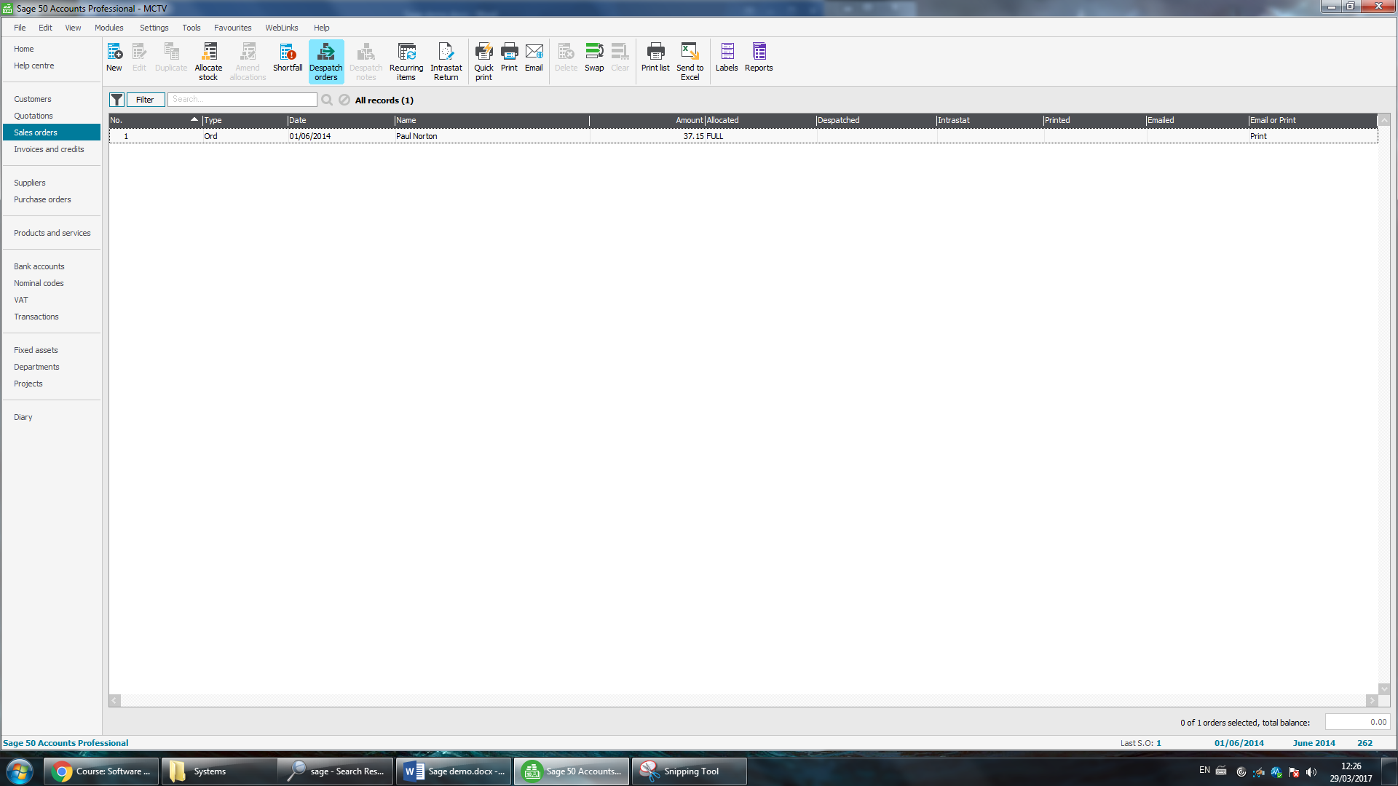

***Creating an Invoice.***

